PRESS RELEASE EMBARGOED 20.09.2018

DE BORDA ABROAD: AN ECOLOGICAL, PSEPHOLOGICAL ODYSSEY
MAJORITARIANISM -- A CAUSE OF SO MANY ILLS

From Sept 2017 to Sept 2018, from Belfast via the Balkans to Beijing and beyond,
and back again on the Trans-Siberian to Mongolia and Moscow,
a journey, mainly by bus, boat, train and a fold-up bicycle,
with umpteen lectures: critiques of majoritarianism and descriptions of a more inclusive polity.

Ulaanbaatar Beijing and Moscow.

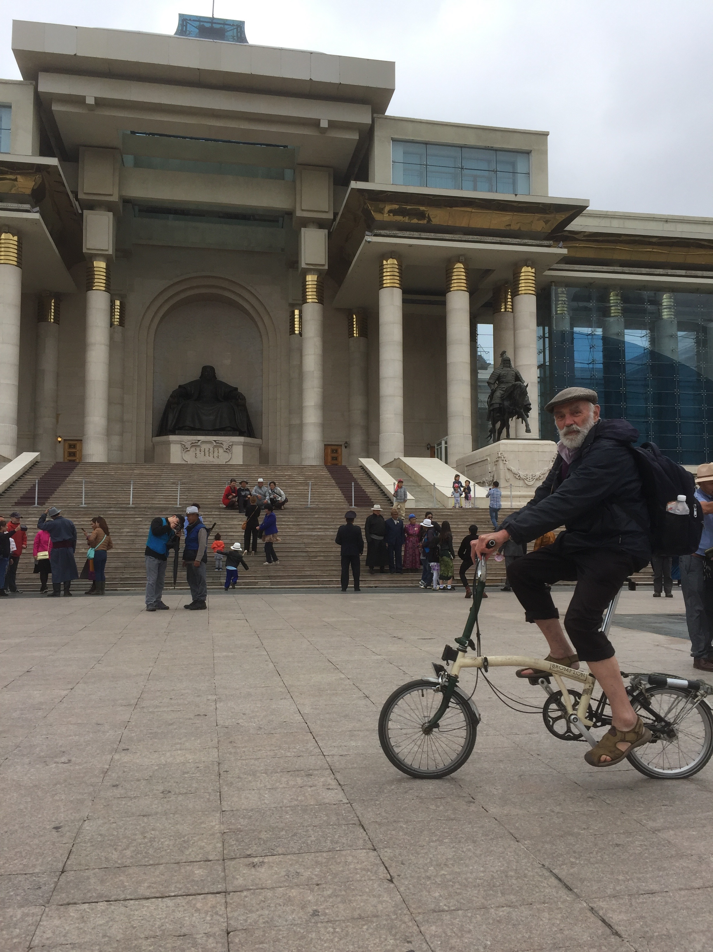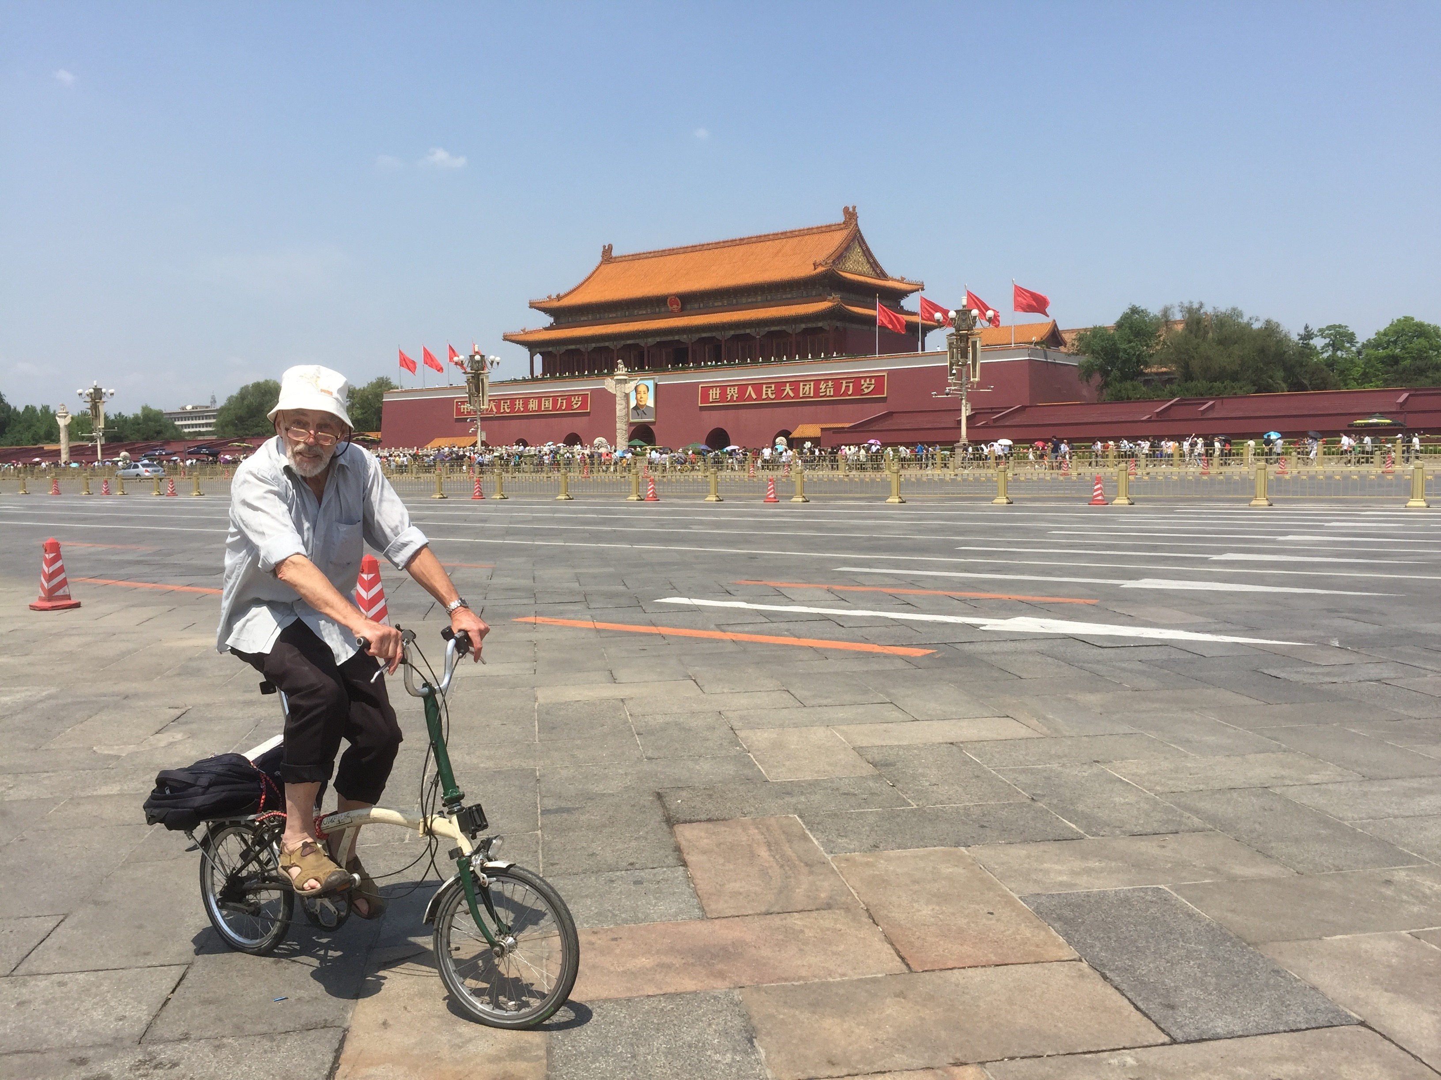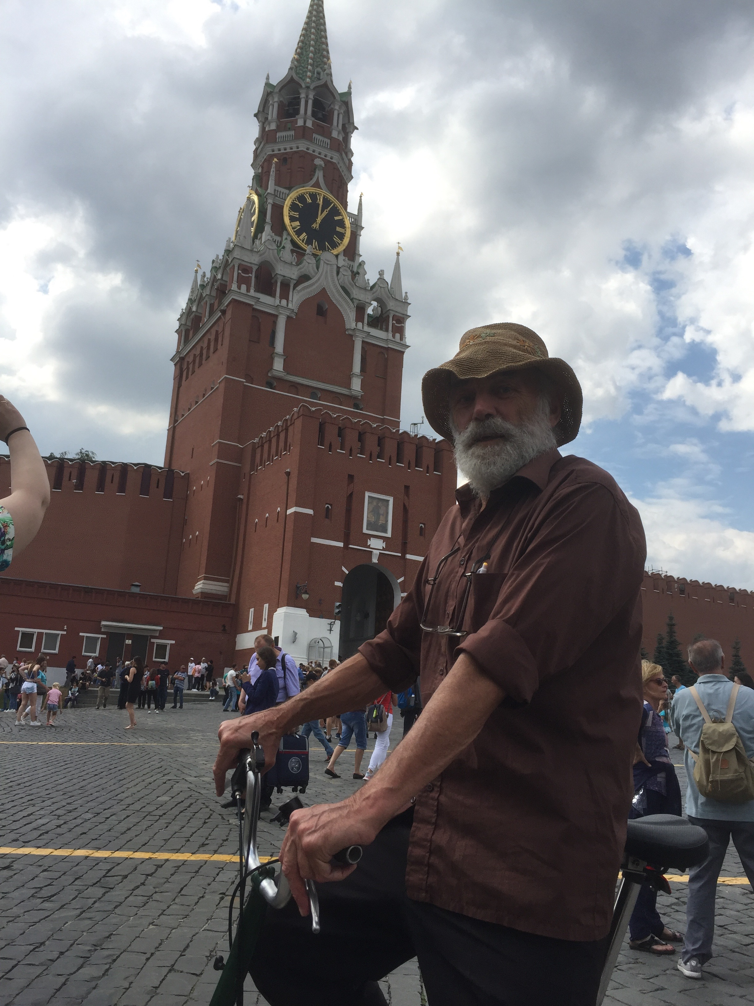

Northern Ireland Majority rule was always part of the problem.
Ireland Citizens’ Assembly calls for multi-option referendums. After 20 years, hoorah!
Britain 2016 refer’dum Brexit did NOT identify the will of the people! Hence today’s arguments.
2017 elections Ugh, the tiny DUP is now in government, while other bigger parties are not?!
Belgium… …holds a world record: 2010/11, 451 days to form a majority coalition govt…
Netherlands 2017 elections The Dutch parliament broke the Dutch record, 225 days…
Germany ” …as did the Bundestag theirs, 161 days.
The Czech Republic ” believes in majority rule but opted for the opposite, a minority administration.
Austria (TEDx talk). ” ‘Only’ 62 days; and the Freedom Party now has more power than its fair due.
The Balkans “All the [1990s] wars started with a [binary] referendum,” (Oslobodjenje, ’99).
Turkey 2017 refer’dum Because of majority rule, the Kurds will probably NEVER be in government.
The Caucasus As in the Balkans, so too here, majority vote referendums have wreaked havoc.
Iran 2017 elections Three referendums, all 99% in favour, of a socialist/capitalist/Islamic Republic.
North Korea… the Democratic People’s Republic. Only yes-or-no elections; like Brexit, really.
Mongolia 2017 elections 30% of polling stations have no electricity. So generators for e-voting. Brilliant!
China Máo Zédōng was a majoritarian, as was…
Russia 2018 elections …Lenin. Indeed, the very word ‘bolshevik’ means ‘member of the majority’.

I gave lectures in Tehran Tiānjīn and Luòyáng (in 2014)
with power-point; plus my TEDx talk; for 200 students;

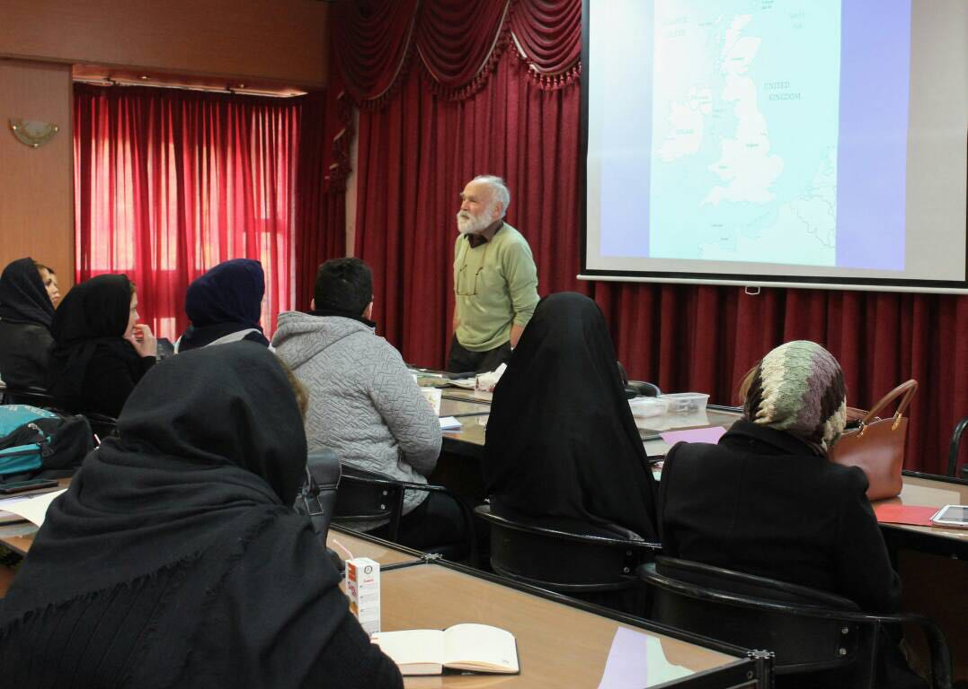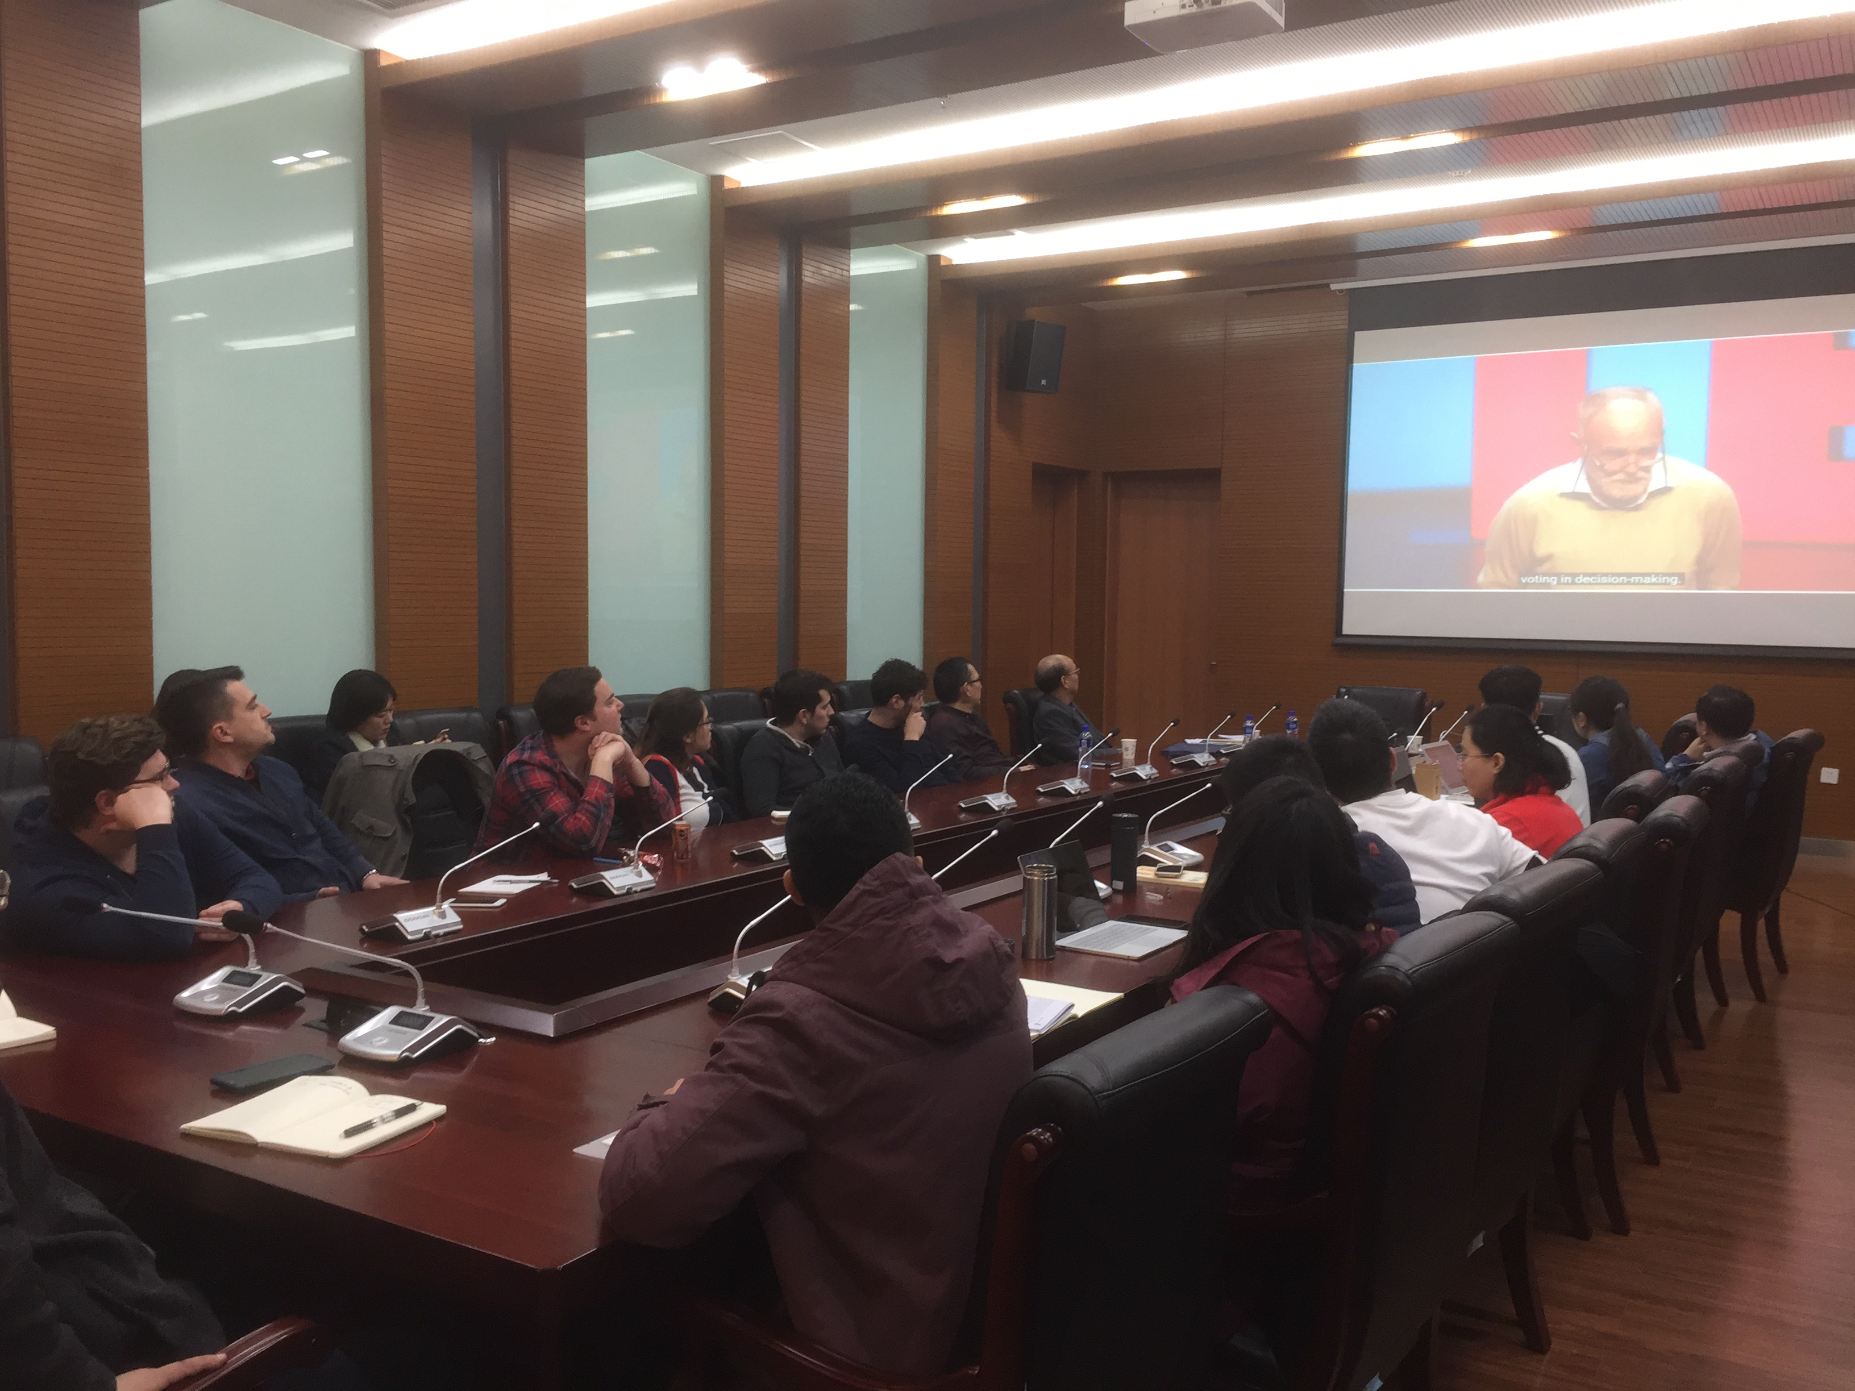

as well as in Leiden, Berlin, Brno, Vienna, Belgrade, Sarajevo, Skopje, Tbilisi, Yerevan, Beijing, Hong Kong and Taiwan.

Largely because of majority voting, political questions are often dichotomous. So politics is usually adversarial.
It need not be so. Preferential points voting, first advocated 800 years ago, could be the basis of a more inclusive polity:
the Modified Borda Count, mbc, in decision-making; preferential, proportional elections; and all-party power-sharing.

Peter Emerson, Director, the de Borda Institute; fluent in Russian, so-so in Serbo-Croat, still struggling in Mandarin.
36 Ballysillan Road, Belfast BT14 7QQ.
07837717979

www.deborda.org pemerson@deborda.org

